
Applications Development Laboratory (ADL)
Individual Work
Lab. No: 1 , Assignment No.: 1
Topic:Functions
Roll Number: | 2305591 | Branch/Section: | CSE-35
Name in Capital: | AKSHAT SHRIVASTAVA

(Instruction: Rename this file as r-AD Lab-x where r is your roll number & x is your lab. number & Suppose your roll number is 1905123 & you want to submit lab-2 programs, then file name should be 1905123-AD Lab-2. Finally delete all texts inside parentheses, also parenthesis)

Program No: 1.1
Program Title: 1. WAP to calculate the factorial of a given number

Input/Output Screenshots:
RUN-1:

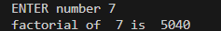

RUN-2
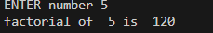

Source code

def fact(n):
f = 1
for i in range(1, n+1):
f *= i
return f

x=int(input("ENTER number "))
print("factorial of ", x ,"is " ,fact(x) )

Program No: 1.2

Program Title: . 2. WAP to calculate the sum of digits of a given number.
Input/Output Screenshots:
RUN-1:

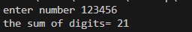

RUN-2

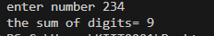

Source code

def fun(n):
sum=0
while(n):
sum+=n%10
n//=10
return sum

x=int(input("enter number "))
print("the sum of digits=",fun(x))

Program No: 1.3

Program Title: 3. WAP to display the reverse of a number entered through keyboard.

Input/Output Screenshots:
RUN-1:

RUN-2
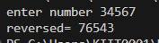

Source code

def fun(n):
rev=0
while(n>0):
d=n%10
rev=rev*10+d
n=n//10
return rev

x=int(input("enter number "))
print("reversed=",fun(x))

Program No: 1.4

Program Title: 4. WAP to find the GCD/HCF of two numbers .umber )

Input/Output Screenshots:
RUN-1:

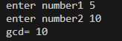

RUN-2

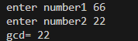

Source code

def gcd(a,b):
while(b):
a=b
b=a%b
return a

x=int(input("enter number1 "))
y=int(input("enter number2 "))
print("gcd=",gcd(x,y))

Program No: 1.5

Program Title: 5. WAP to check whether a number n is prime number or not. /*Hints: A number is a perfect number if is
equal to sum of its proper divisors, that is, sum of its positive divisors excluding the number itself. Write a function to check if a given number is perfect or not. The first perfect number is 6, because 1, 2, and 3 are its proper positive divisors, and 1 + 2 + 3 = 6*/

Input/Output Screenshots:
RUN-1:

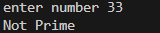

RUN-2

Source code

def prime(n):
flag=True
if n<2:
flag=False
else:
for i in range (2, int(n**0.5)+1):
if n % i ==0:
flag=False
break
print("Prime" if flag else "Not Prime")
x=int(input("enter number "))
prime(x)
Program No: 1.6

Program Title: 6. WAP to print all odd and even numbers separately within a given range. The range is input through
user.
Input/Output Screenshots:
RUN-1:
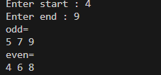

RUN-2

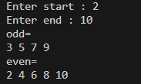

Source code
def odd(n,p)
for i in range(n, p + 1):
if i % 2 != 0:
print(i, end=" ")
def even(n,p):
for i in range(n, p + 1):
if i % 2 == 0:
print(i, end=" ")
start = int(input("Enter start : "))
end = int(input("Enter end : "))
print("odd=")
odd(start,end)
print()
print("even=")
even(start,end)

Program No: 1.7

Program Title: 7. WAP to evaluate the equation y=x n where n is a non-negative integer.

Input/Output Screenshots:
RUN-1:
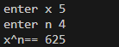

RUN-2
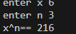

Source code

def fun (n,x):
return x**n
x=int(input("enter x "))
n=int(input("enter n "))
print("x^n==",fun(n,x) )
Program No: 1.8

Program Title: 8. WAP to check whether an input integer is strong number or not. (Hint: If the sum of factorials of all
digits of a number are equal to the number are equal to the number, it is called a strong n

RUN-1:

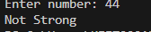

RUN-2
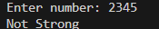

Source code

def factorial(n):
f = 1
for i in range(1, n+1):
f *= i
return f
def is_strong(n):
s = 0
temp = n
while temp > 0:
digit = temp % 10
s += factorial(digit)
temp //= 10
return s == n
x = int(input("Enter number: "))
print("Strong Number" if is_strong(x) else "Not Strong")

Program No: 1.9

Program Title: 9. WAP to check whether an input integer is perfect number or not.
Input/Output Screenshots:

Input/Output Screenshots:
RUN-1:

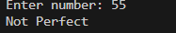

RUN-2

Source code

def fun(n):
s = 0
for i in range(1, n):
if n % i == 0:
s += i
return s

x = int(input("Enter number: "))
s = fun(x)

print("Perfect" if s == x else "Not Perfect")

Program No: 1.10

Program Title: 10. WAP to find out the prime factors of a number entered through keyboard
Input/Output Screenshots:
RUN-1:

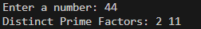

RUN-2

Source code

def prime_factors(n):
factors = []
if n % 2 == 0:
factors.append(2)
while n % 2 == 0:
n //= 2
i = 3
while i * i <= n:
if n % i == 0:
factors.append(i)
while n % i == 0:
n //= i
i += 2
if n > 2:
factors.append(n)
return factors
x = int(input("Enter a number: "))
result = prime_factors(x)
print("Distinct Prime Factors:", *result)

Program No: 1.11

Program Title: 11. WAP to find the first n numbers of a Fibonacci sequence.

Input/Output Screenshots:
RUN-1:
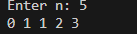

RUN-2

Source code

def fibo(n):
a, b = 0, 1
for _ in range(n):
print(a, end=" ")
a, b = b, a + b
n = int(input("Enter n: "))
fibo(n)

Program No: 1.12

Program Title: 12. WAP to print the series as 1 2 7 15 31 ..........n, where n is given by user.

Input/Output Screenshots:
RUN-1:

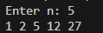

RUN-2

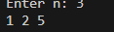

Source code

def special_series(n):
val = 1
for i in range(1, n + 1):
print(val, end=" ")
val = val * 2 + (i - 1)
n = int(input("Enter n: "))
special_series(n)

Program No: 1.13

Program Title: 13. WAP to print the series as 3 5 7 11 13 17..........n, where n is given by user.
Input/Output Screenshots:
RUN-1:

RUN-2

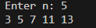

Source code

def is_prime(x):
if x < 2:
return False
for i in range(2, int(x**0.5) + 1):
if x % i == 0:
return False
return True
def prime_series(n):
count = 0
num = 3
while count < n:
if is_prime(num):
print(num, end=" ")
count += 1
num += 1
n = int(input("Enter n: "))
prime_series(n)

Program No: 1.14

Program Title: 14. WAP to sum the following series S=1+(1+2)+(1+2+3)+...+(1+2+3+...+n)

Input/Output Screenshots:
RUN-1:

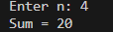

RUN-2

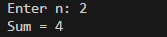

Source code

def sum_series(n):
total = 0
for i in range(1, n + 1):
inner_sum = (i * (i + 1)) // 2
total += inner_sum
return total
n = int(input("Enter n: "))
print("Sum =", sum_series(n))

Program No: 1.15
Program Title: WAP to print the following pattern for n rows. Ex. for n=5 rows

*
* *
* * *
* * * *
* * * * *

Input/Output Screenshots:
RUN-1:
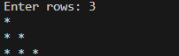

RUN-2
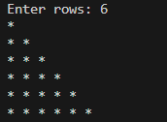

Source code

def star_pattern(n):
for i in range(1, n + 1):
print("* " * i)
n = int(input("Enter rows: "))
star_pattern(n)

Program No: 1.16

Program Title: 16. WAP to print the Following pattern for n rows. Ex. for n=5 rows

*

* *
* * *
* * * *
* * * * *

Input/Output Screenshots:
RUN-1:

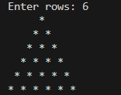

RUN-2

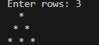

Source code

def star(n):
for i in range(1, n + 1):
print(" " * (n - i), end="")
print("* " * i)

n = int(input("Enter rows: "))
star(n)

Program No: 1.17

Program Title: 17. WAP to print the following pattern for n rows. Ex. for n=6 rows

1
0 1
1 0 1
0 1 0 1
1 0 1 0 1
0 1 0 1 0 1

Input/Output Screenshots:
RUN-1:

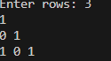

RUN-2

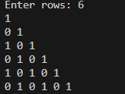

Source code

n = int(input("Enter rows: "))
for i in range(1, n + 1):
start = 1 if i % 2 != 0 else 0
for j in range(i):
print(start, end=" ")
start = 1 - start # alternate 1 ↔ 0
print()

Program No: 1.18

Program Title: 18. WAP to print the following pattern for n rows. Ex. for n=5 rows

A
B A
C B A
D C B A
E D C B A

Input/Output Screenshots:
RUN-1:

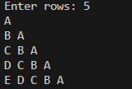

RUN-2
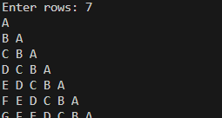

Source code

n = int(input("Enter rows: "))

for i in range(n):
for j in range(i, -1, -1):
print(chr(65 + j), end=" ")
print()

Program No: 1.19

Program Title: 19. WAP to print the following pattern for n rows. Ex. for n=5 rows

1
2 1
1 2 3
4 3 2 1
1 2 3 4 5

Input/Output Screenshots:
RUN-1:
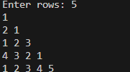

RUN-2

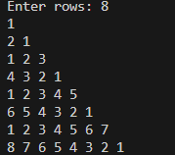

Source code

n = int(input("Enter rows: "))
for i in range(1, n + 1):
if i % 2 != 0:
for j in range(1, i + 1):
print(j, end=" ")
else:
for j in range(i, 0, -1):
print(j, end=" ")
print()

Program No: 1.20

Program Title: WAP to form reverse pyramid of numbers for a given number. Ex. for number 4

1 2 3 4 3 2 1
1 2 3 2 1
1 2 1
1

Input/Output Screenshots:
RUN-1:
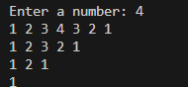

RUN-2

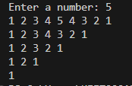

Source code

def reverse_pyramid(n):
for i in range(n, 0, -1):

for j in range(1, i + 1):
print(j, end=" ")

for j in range(i - 1, 0, -1):
print(j, end=" ")

print()

num = int(input("Enter a number: "))
reverse_pyramid(num)

Program No: 1.21

Program Title: 21. WAP to generate the pascal triangle pyramid of numbers for a given number. Ex. for number 4

1
1 1
1 2 1
1 3 3 1
1 4 6 4 1

Input/Output Screenshots:
RUN-1:

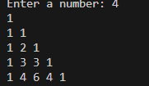

RUN-2
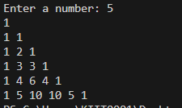

Source code

def triangle(n):
for i in range(n + 1):
c = 1
for j in range(i + 1):
print(c, end=" ")
c = c * (i - j) // (j + 1)
print()

num = int(input("Enter a number: "))
triangle(num)

Program No: 1.22

Program Title:
22. WAP to display the following style o/p for a given string input through keyboard.(Ex.for a string
“KIITCSIT”)

KIITCSITTISCTIIK
KIITCSI ISCTIIK
KIITCS SCTIIK
KIITC CTIIK
KIIT TIIK
KII IIK
KI IK
K K
KI IK
KII IIK
KIIT TIIK
KIITC CTIIK
KIITCS SCTIIK
KIITCSI ISCTIIK
KIITCSITTISCTIIK

Input/Output Screenshots:
RUN-1:
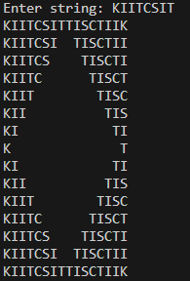
RUN-2
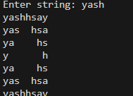

Source code

def string_pattern(s):
n = len(s)
rev = s[::-1]

for i in range(n):
left = s[:n - i]
right = rev[:n - i]
print(left + " " * (2 * i) + right)

for i in range(n - 2, -1, -1):
left = s[:n - i]
right = rev[:n - i]
print(left + " " * (2 * i) + right)

text = input("Enter string: ")
string_pattern(text)

Program No: 1.23

Program Title: 23. WAP to convert a decimal number into its equivalent number with base b. Decimal number and b are
the user input.

Input/Output Screenshots:
RUN-1:

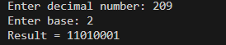

RUN-2
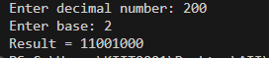

Source code

def decimal_to_base(n, b):
digits = ""

while n > 0:
rem = n % b
digits = str(rem) + digits
n //= b

return digits

num = int(input("Enter decimal number: "))
base = int(input("Enter base: "))

print("Result =", decimal_to_base(num, base))

Program No: 1.24
Program Title: 24. WAP to convert a number with base b into its equivalent decimal number. Number with base b & b are
the user input.

Input/Output Screenshots:
RUN-1:
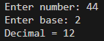

RUN-2

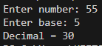

Source code

def base_to_decimal(number, base):
number = number.upper()
value = 0
power = 0

for digit in number[::-1]:
if digit.isdigit():
num = int(digit)
else:
num = ord(digit) - 55

value += num * (base ** power)
power += 1

return value

num = input("Enter number: ")
base = int(input("Enter base: "))
print("Decimal =", base_to_decimal(num, base))

Program No: 1.25

Program Title: 25. WAP to convert a binary number to its equivalent octal & hexa-decimal number system.

Input/Output Screenshots:
RUN-1:
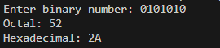

RUN-2
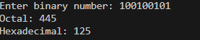

Source code

def binary_to_decimal(b):
value = 0
power = 0
for digit in b[::-1]:
value += int(digit) * (2 ** power)
power += 1
return value
def decimal_to_octal(n):
result = ""
while n > 0:
result = str(n % 8) + result
n //= 8
return result or "0"
def decimal_to_hex(n):
hex_digits = "0123456789ABCDEF"
result = ""
while n > 0:
result = hex_digits[n % 16] + result
n //= 16
return result or "0"
binary = input("Enter binary number: ")
dec = binary_to_decimal(binary)
print("Octal:", decimal_to_octal(dec))
print("Hexadecimal:", decimal_to_hex(dec))

